BAKED EGGPLANT & BEAN STEW
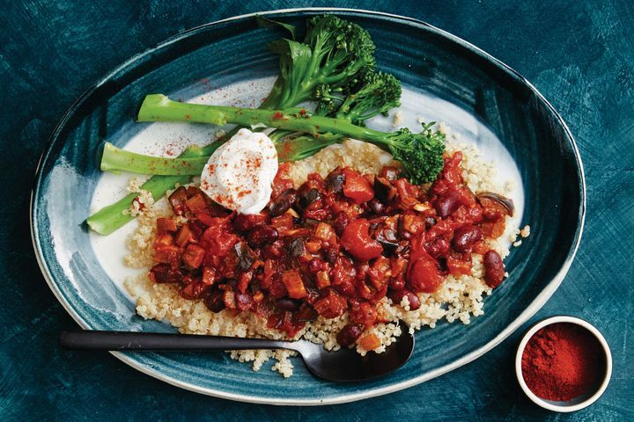

Ingredients
- 1 tablespoon extra virgin olive oil
- 2 small or 1 large eggplants, cut into 2cm pieces
- 1 large red onion, finely chopped
- 3 celery sticks, cut into 1cm pieces
- 2 garlic cloves, thinly sliced
- 2-3 tsps harissa paste, to taste
- 1 tsp smoked paprika, plus extra, to serve
- 1 tsp ground cumin
- 400g can red kidney beans, rinsed, drained
- 400g can diced tomatoes

- 300g (2 cups) steamed white quinoa
- steamed broccolini, to serve
- 90g (1/3 cup) yoghurt

Method
- Preheat oven to 170C/150C fan forced.
- Heat half the oil in a large flameproof casserole dish over high heat. Cook the eggplant, in 2 batches, stirring, for 3-4 minutes or until browned. Transfer to a plate.
- Heat the remaining oil in the pan over medium heat. Add the onion and celery. Cook, stirring often, for 5 minutes or until soft.
- Add the garlic, harissa, paprika and cumin. Cook, stirring, for 1 minute or until aromatic.
- Add the beans, tomatoes, eggplant and 125ml (1 ⁄2 cup) water. Stir to combine then bring to the boil.
- Cover and bake for 30 minutes or until the eggplant is very tender.
- Divide the quinoa and stew among serving plates. Serve with broccolini, a dollop of yoghurt and a sprinkle of extra paprika.

